Dispatch Goods

Central ware House coordinators use this system to dispatch requisition goods.

They can log in to Requisition Dispatch system by following this path.

- APMaS Web Page Ware House Requsion Despatch

APMaS Web Page
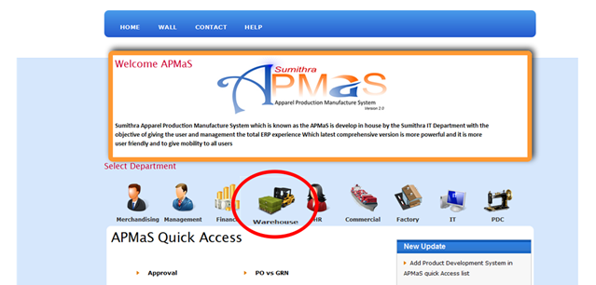

Ware House

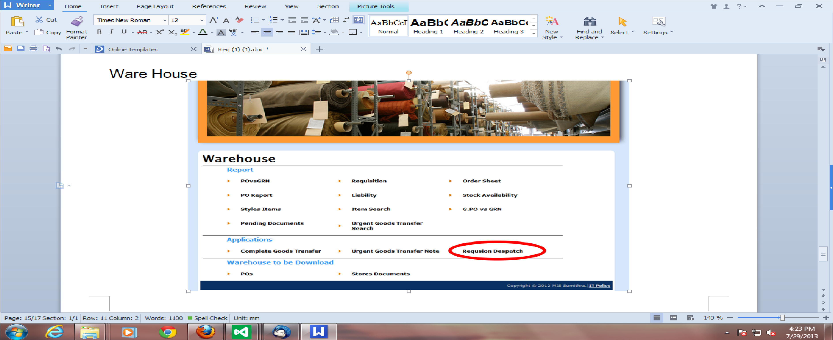

Now user can search approved requisitions. They have three ways to search a requisition.

- style vice
- requisition number vice
- selecting location and buyer vice.

First, user must select a method and put a tick to it. Then give relevant details and click search button or view button.

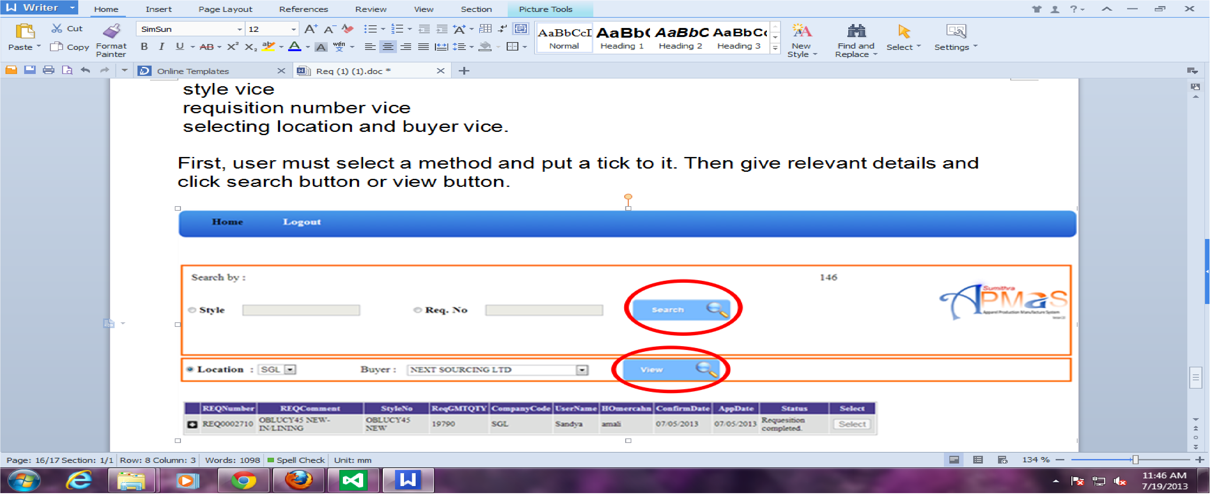

And then the search results will be displayed below.
After selecting a requisition, user will be directed to the goods dispatch page.

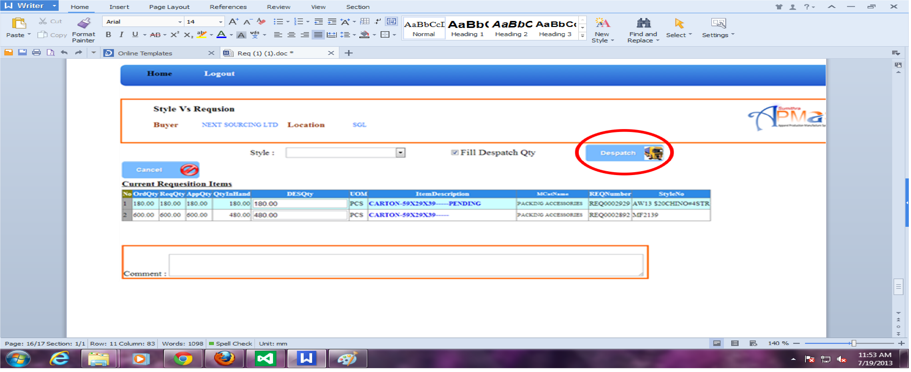

Now user can view approved requisition quantity from HO merchandisers. Then user can fill Dispatch quantity by him/herself. And click “Dispatch” Button to confirm the dispatch, then requisition will be completed and the system will automatically create a Transfer Note.

